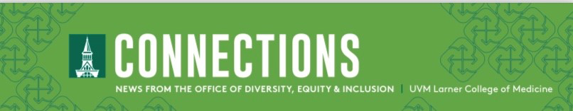
September 2023

Observances
- 9/6-7 | Krishna Janmashtami (A celebration for Hindus celebrating the birth of Krishna)
- 9/15-17 | Rosh Hashanah (Jewish New Year and the start of the High Holy Days, a period of penitence and reflection)
- 9/21 | First Day of Fall
- 9/21-29 | Mabon/Alban Elfed/ Autumnal Equinox
- 9/24-25 | Yom Kippur (A Jewish holiday for fasting and atonement)
- 9/29-10/6 | Sukkot (A week-long Jewish celebration of the harvest and protection granted to the people of Israel after they escaped slavery)

Events
- 9/19 | Imbasciani LGBTQ Health Equity Lecture – Gender-Affirming Care as a Model for Healthcare – Dallas Ducar, MSN, APRN, FAAN. Join us via Zoom!
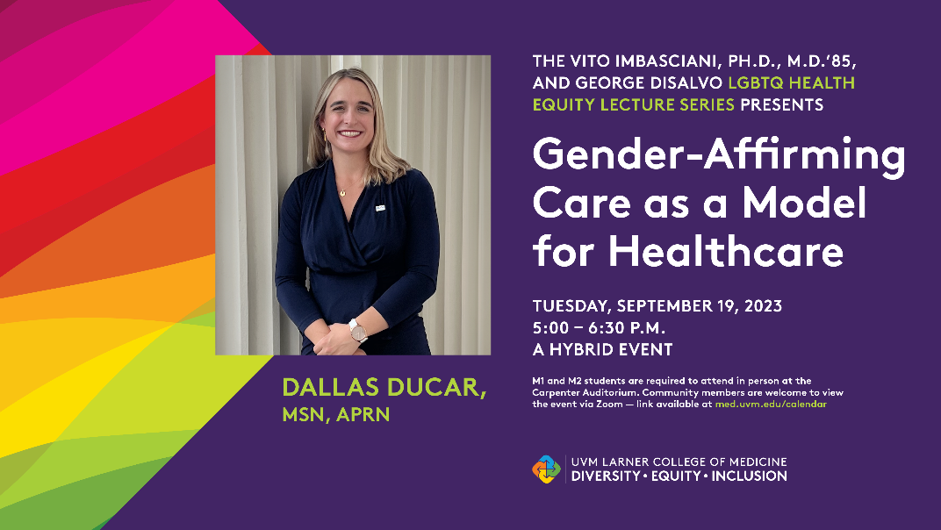

- Missed an event? Visit our video library

Join the Gender Equity Listserv!
Want to keep up to date on Gender Equity events and initiatives? Join the Gender Equity Listserv

Office of Diversity, Equity, and Inclusion (ODEI) News

Tandoh Receives HEDIC Certificate
By Tiffany Delaney

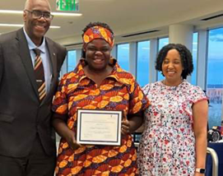Margaret Tandoh, MD, FACS, Associate Dean for Diversity, Equity and Inclusion, recently completed the Healthcare Executive Diversity and Inclusion Certificate (HEDIC) sponsored by the AAMC. The HEDIC curriculum focuses on applied skills that will assist participants in successfully implementing diversity projects at their home institutions. Dr. Tandoh’s project is Creating a Retention Program for URiM Faculty at the Larner College of Medicine.

Larner College of Medicine DEI

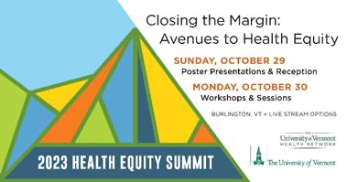
Register for the 2023 Health Equity Summit
Registration is open for the second annual Health Equity Summit. The Summit will showcase the exciting initiatives being implemented across our local and extended communities to dismantle institutional inequities that can lead to poor health outcomes while improving patient experience, inspiring our communities and advancing health equity.
You can register here.
We are also seeking student volunteers to help with logistics and accessibility. If you would like to volunteer, please contact hes@uvm.edu.

Department of Orthopaedics and Rehabilitation McClure Musculoskeletal Research Center presents:

2023 John W. Frymoyer Lecture Series
Visiting Professor: Kimberly J. Templeton, MD
Professor of Orthopaedic Surgery
University of Kansas Medical Center

What Are Sex and Gender Impacts On Musculoskeletal Conditions?
Wednesday, September 13, 2023, 5:30–6:30 PM
Robert Stafford Hall, Room 410
VIA ZOOM https://uvmcom.zoom.us/j/108497630

Should We Be Looking for Sex-Based Differences In Musculoskeletal Conditions?
Thursday, September 14, 2023, 7:00–8:00 AM
Robert Stafford Hall, Room 101
VIA ZOOM https://uvmcom.zoom.us/j/108497630

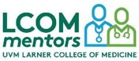Become a Faculty Mentor to a Medical Student
The LCOM Mentors program pairs medical students who are members of groups underrepresented in medicine* with faculty members and/or residents who have common interests and goals. (see our definition of underrepresented in medicine below). This relationship can support the medical student (the mentee) to become familiar with institutional expectations, networks, and practices that are relevant to productivity and advancement at the Larner College of Medicine (LCOM).

Research has supported the importance of mentoring for medical education satisfaction and achievement. Research reports that mentors also gain a variety of tangible and intangible benefits from the mentoring process.

Guiding Principles - The LCOM Mentors program ascribes to a structured mentoring format based upon a guiding list of principles. In addition to matching mentors with mentees, we will also provide various programmatic features to support mentoring pairs---such as training, faculty development tips and workshops.

For more information or to sign up, please fill out this short form.

Call for ELAM/ELH Nominations
The Hedwig van Ameringen Executive Leadership in Academic Medicine® (ELAM®) Program for Women and the Executive Leadership in Health Care(ELH) Program are accepting nominations for the 2024-25 cohorts. The Larner College of Medicine and the UVMHNMG will support a highly qualified women Associate Professor to the competitive selection process for each program.
Interested women faculty should discuss nomination with their chair and send a one page statement of interest and their CV to Krista.koeller@med.uvm.edu

North Star Collective Faculty Fellowship Call for Applications
The New England Board of Education invites applications for the North Star Faculty Fellowship, a semester-long professional development opportunity focused on healing, support, and well-being for early-career BIPOC faculty. Applicants should send a CV and 2 page personal statement, and writing sample to reparativejustice@nebhe.org by November 1st, 2023 at 11:59.

From the AAMC
As climate change fuels more extreme weather, clinics for the underinsured are at the frontlines of the health care response
Harvard researchers have collaborated to create evidence-based resources to help frontline clinics prepare for extreme weather.
Read More

VaccineVoices: Inside efforts to provide health care to youth who are unhoused
Hospitals are partnering with community organizations and local health and housing agencies to meet the medical needs of teenagers.
Read More

Articles of Interest

A How Far Back Were Africans Inoculating Against Smallpox? Really Far Back.
By Elise A. Mitchell
When one thinks of the history of inoculation, they usually start with Edward Jenner and the invention of the smallpox vaccine in 1796, but its history goes much farther back.

Read More →
A New Paper Defends the Use of Race in Medicine. Not Everyone is Convinced
By Jon Edelman
Evidence about the pernicious influence of racism on medical care continues to grow, and calls have intensified for the medical field to stop using race when making clinical decisions. However, some argue that even if race is a social construct, what matters in determining its use is whether or not it has predictive power.

Read More →

Long Covid Recovery Remains Rare. Doctors Are Struggling to Understand Why
By Jaimie Ducharme

Only 15% to 20% of people with Long Covid report making a complete recovery, and reliable, effective treatments remain elusive. More clinical trials are needed to develop treatments as the number of people disabled by SARS Cov-2 continues to rise.

Read More →

