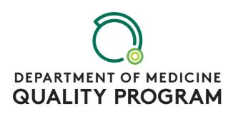**Scholarly QI Poster Session**

Are you currently working on a scholarly QI initiative that you would like to share with your colleagues? Did you present QI work at a regional or national meeting this past year?

Present your work at the **Department of Medicine Scholarly QI Poster Session**—

**Who?** This opportunity is open to faculty, fellows, residents, and students who have a faculty mentor in the Department of Medicine.

**What?** Present a poster summarizing your recent scholarly QI work. This work may be completed in the past year or still in progress.

**When?** 9-10 AM on Friday, April 19, 2019 – immediately following Grand Rounds

**Where?** Davis Concourse – outside of the Davis Auditorium

**How?**

1. **Register** by sending an e-mail with the following information to [allen.repp@uvmhealth.org](mailto:allen.repp@uvmhealth.org):
   1. Poster Title:
   2. Presenter:
   3. Team members / co-authors:
   4. Category: (1) Completed Work or (2) Work-in-Progress
2. **Poster format**
   1. Presenters may use posters that have been presented within the past year at other professional conferences or posters that will be presented at future professional conferences.
   2. Presenters may develop a poster of completed scholarly QI work or work-in-progress specifically for the Department of Medicine QI Poster Session. For those developing new posters, the recommended poster size is 36x48 inches. Larner College of Medicine scientific poster templates can be found at <https://www.med.uvm.edu/medcommunications/graphicstoolbox> (although there is no requirement to use one of these templates).
3. **Hang your poster(s)** between 7-8 AM on Friday, April 19 on the bulletin boards outside of Davis Auditorium.
4. Be available to **discuss you poster(s)** with colleagues from 9-10 AM on Friday, April 19.