Maximize the Value of Your Mentoring Meetings
To help establish a solid partnership with your mentee and ensure that you are addressing both overall goals and everyday issues, consider applying the "10/20/30 Rule" when you meet.

One-hour Meeting

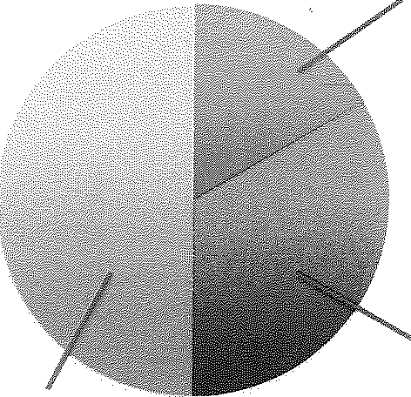
Last 30 Minutes: Discuss current and Jong-term goals and priorities.

First 10 Minutes: Engage in a personal and professional
“check-in.”

Next 20 Minutes: Focus on "front burner" issues (for example, upcoming presentations, manuscript revisions).

Adapted from Feldman, M. D. (2010). UCS Mentoring Facilitator Toolkit. Retrieved from http://academicaffairs.ucsf.edu/mentoring/Faculty%20Mentoring%20Program%20Toolkit.pdf

