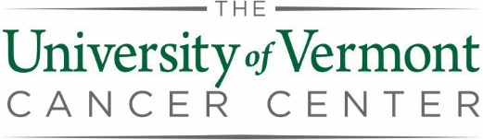
2020 Pilot Project
Letter of Intent (LOI)
- What is the title of the proposed research project?
- Please list Key Personnel, expanding or adding boxes as needed. Principal Investigator(s) (PD/PI or co-PI) must be Full or Associate University of Vermont Cancer Center (UVMCC) Members and at least one PI must be a Full member. LOIs from investigators whose applications for UVMCC Membership have been submitted but are pending will be provisionally accepted. Please let us know if there are changes in Key Personnel after the LOI is submitted so that we can manage potential conflicts of interest when assigning reviewers.
Key Personnel  Investigator Name & Degree(s)  (e.g., Jayne P. Smith, MD, PhD) | Department or Division, College, University (if not UVM), or other affiliation. | Project Role | Member Level | Program
 |  | Choose an item. | Choose an item. | Choose an item.
 |  | Choose an item. | Choose an item. | Choose an item.
 |  | Choose an item. | Choose an item. | Choose an item.
 |  | Choose an item. | Choose an item. | Choose an item.
 |  | Choose an item. | Choose an item. | Choose an item.
 |  | Choose an item. | Choose an item. | Choose an item.
 |  | Choose an item. | Choose an item. | Choose an item.
 |  | Choose an item. | Choose an item. | Choose an item.
 |  | Choose an item. | Choose an item. | Choose an item.
 |  | Choose an item. | Choose an item. | Choose an item.

- Please provide a few keywords or subject areas that describe your research project. Use as many or as few as you feel will help in identifying the best qualified reviewers.

- Is this a resubmission? Yes ☐ No ☐

- If yes, when was it last submitted?

- Project Summary: In a few sentences, please provide a broad outline of your proposed research.

- Attach NIH format Biosketches for Key Personnel. CVs will be accepted for LOIs but NIH format biosketches will be required with full application.

- Combine LOI and Biosketches into a single PDF and send to edward.north@uvm.edu with “UVMCC Pilot Project LOI” in the subject line.

Important Dates:
Letters of Intent are due by noon on Monday, July 22, 2019
Full Applications are due by noon on Monday, September 23, 2019
Award Notification will take place by Wednesday, December 4, 2019
Projects Start Wednesday, January 1, 2020

Please go to the UVMCC Intramural Funding Web Page
to download forms and related materials.

