Steps to Create an Interprofessional Practice and Education (IPE) Activity/Project
*Adapted from ASHA steps for designing IPE curriculum and faculty development
Step 1: Who do you want to collaborate with to create this activity?
Step 2: Who are the learners for this IPE activity/project?

*Participants can include students (medicine, nursing, athletic training, communication sciences and disorders, exercise science, health science, counseling, radiation sciences, pharmacy, social work, dietetics and nutrition, and others), educators, clinician educators, healthcare practitioners, administrators, patient, family, or community organizations.

**Remember-it doesn’t need to include all the professions! Can be a smaller IPE activity with at least two professions.
Step 3: Identify at least three learning outcomes for the session utilizing IPEC Core Competencies and Blooms Taxonomy.

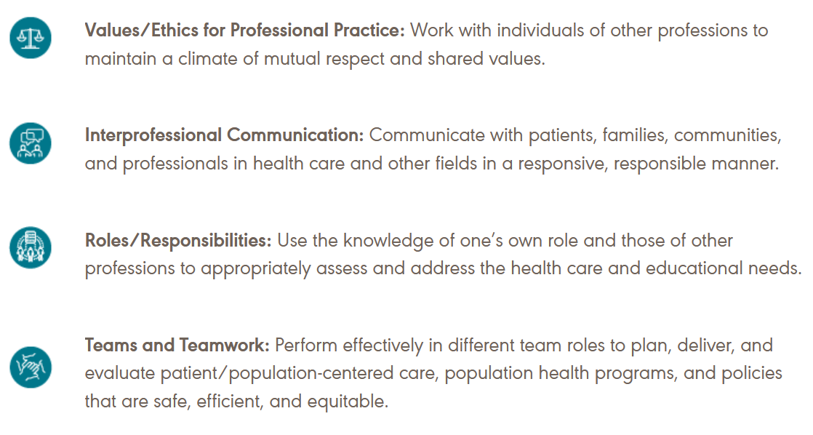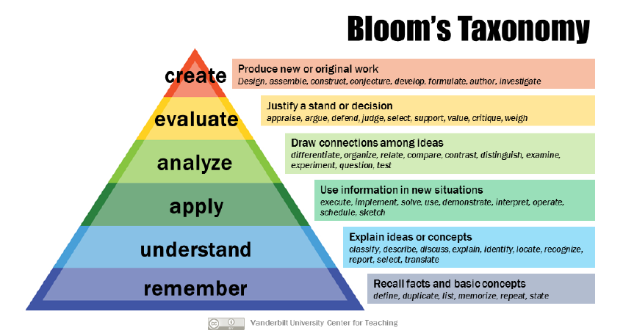

Step 4: What type of activity would you like to create? Select all that apply:
Simulation Case-study Skills competency Clinical experience Lab experience Other ______________________________________________________

Step 5: Describe the activity in more detail.
Step 6: Practicalities to run the session. Who can help with scheduling and funding?
Step 7: How will you assess the session? Select all that apply:
Quiz Written reflection Participation Survey Group Assessment
Other ___________________________________________

Step 8: Are there any additional needed resources for session? (e.g. food, equipment, technology, supplies)
Step 9: What are your next steps to make this session a reality?

References
American Speech-Language-Hearing-Association (2024). How to: Seven steps for designing interprofessional education curriculum and professional development. Retrieved from https://www.asha.org/practice/ipe-ipp/how-to/seven-steps-for-designing-interprofessional-education-curriculum-and-professional-development/.
Cisco Consulting LLC (2023). Vermont nursing. Workshop 1 presentation [PowerPoint slides].
Interprofessional Education Collaborative (2023). IPEC core competencies for interprofessional collaborative practice: version 3. Washington, D.C.

