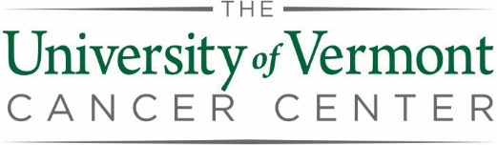

2020 Supplemental Pilot Projects
Application Checklist
For application submission, please assemble items in the following order into one PDF and send by email to edward.north@uvm.edu with “UVMCC Pilot Project Application” in the subject line.

ITEM | Limit
- Title | As Needed | ☐
- Key Personnel | As Needed | ☐
- Key Words | Six or fewer | ☐
- Resubmission? | NA | ☐
- Prior Funding | As Needed | ☐
- Overlap | As Needed | ☐
- Regulatory Approvals | NA | ☐
- Shared Resources | NA | ☐
- Lay Summary | 3-4 sentences | ☐
- Abstract | 1 page | ☐
- Leadership Plan | 1 page | ☐
- Specific Aims | 1 page | ☐
- Research Strategy | 5 pages | ☐
- Response to Reviewers (for resubmissions only) | 1 page | ☐
- Literature Citations | As Needed | ☐
- Budget | As Needed | ☐
- Budget Justification | As Needed | ☐
- Departmental Approvals | As Needed | ☐
- Facility Head Approval | As Needed | ☐
- NIH format Biosketches for Key Personnel | 5 pages each | ☐
- Letters of Collaboration or Letters of Support (optional) | As Needed | ☐

Important Dates:
Applications are due by noon on May 11, 2020
Award Notification will take place by mid-June 2020
Projects Start July 1, 2020

In recognition of the extraordinary clinical demands resulting from COVID-19, applications for Translational and Clinical Projects will be solicited at a later date. The initial round of 2020 supplemental awards will be for basic science proposals only.

Please go to the UVMCC Intramural Funding Web Page
to download forms and related materials.

