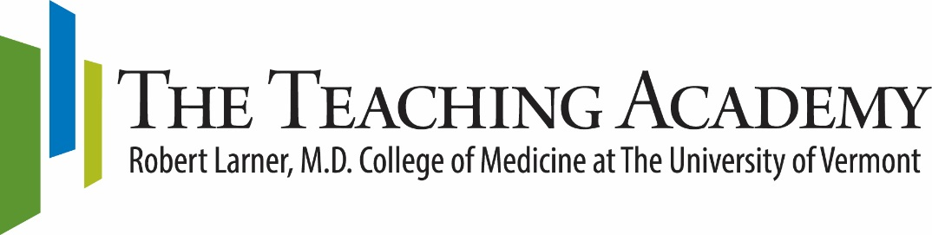
2019-2020 Medical Education Fellowship Program

The Medical Education Fellowship Program is a monthly, cohort-style program for Larner College of Medicine faculty who seek additional preparation for teaching and educational scholarship across the medical education continuum. Participants will review principles of learning and development, discuss teaching and learning issues with colleagues, and develop instructional and assessment strategies. Participation in the program will also include mentorship for a scholarly project in education suitable for presentation and publication. The program consists of interactive, seminar-style sessions and readings. An active learning approach will be used, i.e., materials will be available in advance of each session and participants will be expected to draw upon and apply the materials during the sessions. Participants will also have the opportunity to observe teaching sessions and receive feedback on their own teaching.

Approximately 8-10 faculty members will be selected for participation in the Medical Education Fellowship Program. While designed for early to mid-career faculty members, faculty with teaching experience who are interested in expanding their teaching skills and scholarship may also apply. Participants are expected to undertake a curriculum development initiative or other teaching-related project suitable for presentation and publication. The primary facilitator is Katie Huggett, Ph.D., Director of the LCOM Teaching Academy. Additional faculty and staff will co-facilitate or share resources and expertise at individual sessions.

Prerequisite: Applicants without previous preparation for teaching are advised to complete the 1-day Essentials of Teaching and Assessment course on September 13, 2019.

Location: Dana Medical Library Classroom, UVM Larner College of Medicine

Schedule: Monthly sessions, 9:00-11:00 AM on Friday morning. Additional consultation time may be available following monthly sessions, from 11 AM - 12 PM.
*January’s session will be on Thursday to coincide with the Snow Season Education Retreat

Dates: October 11, November 22, December 13, January 16*, February 14, March 13, April 3, May 1, June 5

October 11 | Session 1 A: Introductions and brief project presentations  Session 1 B: Developing Curricula and Educational Experiences
November 22 | Session 2 A: Studying your Teaching  Session 2 B: Conceptual Frameworks and Theories
December 13 | Session 3 A: Dana Medical Library Resources for Educators  Session 3 B: Project Session
January 16* | Session 4: Snow Season Education Retreat
February 14 | Session 5: Career Development for Educators
March 13 | Session 6: Using Assessment Data to Improve Teaching
April 3 | Session 7: Promoting Active Learning
May 1 | Session 8: NEGEA 2020 Annual Conference
June 5 | Session 9: Wrap –up and Project Presentations

2019-2020 Medical Education Fellowship Program Application

Name: | Position:
Department: | Email Address:
Primary Phone: | Secondary Phone:

Approximately 8-10 faculty members will be selected for participation in the Medical Education Fellowship Program. While designed for early to mid-career faculty members, faculty with teaching experience who are interested in expanding their teaching skills and scholarship may also apply. Participants are expected to undertake a curriculum or assessment project, or other teaching-related project suitable for presentation and publication.

Applicants to the Medical Education Fellowship Program should submit the following:
- This Application Form page with contact information.
- Cover letter expressing your interest in the program. Please address the following questions: Why are you interested in the Medical Education Fellowship Program? What will you contribute to the experience? How do you envision participation in the program will improve your teaching?
- One-page proposal for a scholarly project you will undertake during the program. Project examples include a plan to develop a new course/curriculum; a proposal for a teaching or assessment innovation; or a small-scale research study related to some aspect of your teaching.
- Copy of your CV.
- Letter of support from your Department or Program Chair.

Important Dates:
- Application Deadline: June 24, 2019
- Participants will be notified on or before July 12, 2019

Schedule: Monthly sessions, 9:00-11:00 AM on Friday morning. Additional consultation time may be available 11 AM - 12 PM following monthly sessions. * January’s session will be on Thursday, 1/16 to coincide with the Snow Season Education Retreat

Dates: October 11, November 22, December 13, January 16*, February 14, March 13, April 3, May 1, June 5

Location: Dana Medical Library Classroom, UVM Larner College of Medicine

Please email or send this completed application to: Amanda Broder via teaching.academy@med.uvm.edu
Questions about the Program? Contact Katie Huggett, PhD Kathryn.huggett@med.uvm.edu

