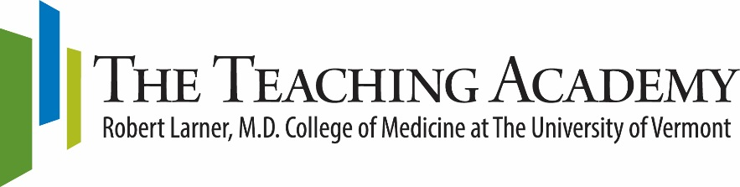

Teaching Academy Travel Award

The Teaching Academy at the Larner College of Medicine sustains and supports an interdisciplinary community of educators who value the scholarship of teaching and learning while facilitating educator development; improve the efficiency and quality of medical education through collaboration and scholarship; and promote an academic environment that increases the value and impact of educators locally, regionally, and nationally. The Teaching Academy is pleased to announce that we will award three travel awards to support member travel to present educational scholarship or attend professional development events related to the mission of the Teaching Academy.

Eligibility | Any LCOM Teaching Academy member. Preference will be given to those who will present scholarly work at the conference or meeting, or participate in a fellowship-type program.
Deadline | Applications must be submitted by midnight April 30, 2018.
Notification | Awardee(s) will be contacted by June 1, 2018.
Travel Completion | Travel must be completed by June 30, 2019
Amount | A maximum of $1000 per award
Required Application  Components | - Completed application  - Curriculum Vitae (CV)
Submit to | The Teaching Academy  teaching.academy@med.uvm.edu

Teaching Academy Travel Award Application

Please complete this application and submit to the Teaching Academy no later than April 30.
Please include your CV. You may type your text but please limit total completed pages to two.

Name

Email

Department

Primary Teaching
Responsibility

Additional Teaching
Responsibilities
(relevant to this application)
Name of Conference or Faculty Development Event
Date
Location
URL for event information
Are you on the program or presenting at this event?
If yes, please describe.

- Why are you interested in attending this meeting? How will attending this conference or event advance your career as an educator?

- How will attending this conference or event enhance the efficiency and quality of medical education at the Larner College of Medicine?

By signing this application you are acknowledging you must comply with applicable university travel guidelines. You are also acknowledging you agree to submit a written report within 4 months after attending the event OR offer a faculty development session to share your experience and knowledge gained with other academy members and LCOM colleagues.

Sign: ____________________________________________________________

