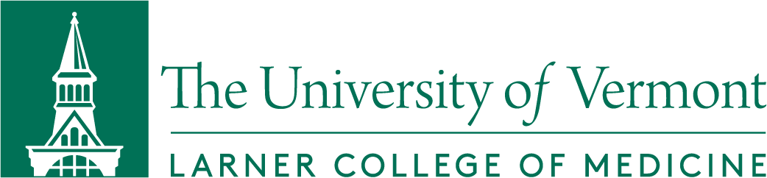

Dean’s Advisory Committee on Diversity, Equity and Inclusion
Meeting Minutes
Friday, January 22, 2020
Present: Richard Page, M.D., Margaret Tandoh, M.D., Ellen Black, Ph.D.; Elizabeth Bonney, M.D.; Brian Kim, M.D.; Macaulay Onuigbo, M.D.; Marie Sandoval, M.D.; Anthony Williams, M.D.; Raj Chawla, M.P.H.; Julie Chiappinelli; Elizabeth McElhinney, M.Ed.; Sarah Keblin, M.P.A.; Jeff Rector; Melanie Sestokas; Reed Hausser, MSIV; Victor Abraham, MSII; Charles Irvin, Ph.D.; Associate Dean for Faculty Affairs; Lee Rosen, Ph.D., Interim Associate Dean of Students; Gordon Jensen, Ph.D. Nathalie Feldman, M.D.; Chris Berger, Ph.D.; Karen Lounsbury, Ph.D.; Michelle Bookless

Absent: Adam Ross, MSIII, Brian Cote

Agenda Item
Welcome
DACDEI Representation – CT Campus | Dean Page discussed adding representation on DACDEI from CT campus.  Q: should there be more than one rep. from CT, to include faculty, staff and students?  ODEI will send announcement for DACDEI reps to J. Rosen for distribution to CT campus.
Review and Discussion of LCME Standard 3.3 (Diversity) and  LCOM DCI Submission | This was moved up to second agenda item.  RETENTION:  Q: the loss of BIPOC staff in OMSE and other departments at LCOM. Are exit interviews conducted with staff that are leaving?  Dean Zehle indicated that these are done when employees leave.  Q: Where does retention data for staff reside?  UVM staff data is compiled by the OIR.  There needs to be more coordination between LCOM and main campus regarding recruitment and retention efforts.  PIPELINE PROGRAMS: LCME reviews pipelines for both students and faculty/Sr. Admin. Staff  LCOM has no dedicated pipeline programs designed to target students from our priority groups.  Q: Have we thought about creating pipelines for LCOM alumni to come back as faculty?  We should explore programs that guarantee admission to med school as undergrads; loan repayment programs for alumni that return to the faculty  T. Abraham mentioned 4+4 program that guaranteed admission to medical school, residency and loan repayment.  Dean Zehle mentioned that Ryan Hargreaves from main campus admissions is very interested in discussing and developing pipelines and should be brought into the conversation.  T. Delaney shared that it seems like UVM does not leverage its health sciences Colleges to recruit undergrad students.  OFFERS: Tables 3.3—Numbers for Sr. Administrative Staff are all “0”. Q: Are these numbers accurate? Where is the data coming from? Data came from LCOM—and is accurate.  Q: Why do so many med school applicants (BIPOC) offered acceptance turn us down?  L. McElhinney explained the data from declining applicants indicates location and a lack of competitive scholarship are the two main reasons.
Medical Education Anti-Racism Task Force | Dean Zehle provided an overview of the Medical Education Anti-Racism Task Force
Committee Professional Development | M. Upton informed the committee that the February meeting would be devoted to a review of the Everfi eModules.
Next Meeting | Thursday, February 18th 3:00 pm
Adjournment | 4:02 pm

