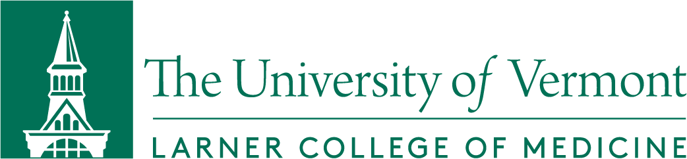

Dean’s Advisory Committee on Diversity, Equity and Inclusion
Meeting Agenda
Friday, January 22, 2020
Zoom; https://uvmcom.zoom.us/j/99588465781

Co-Chairs: Richard Page, M.D., Dean, Larner College of Medicine
Margaret Tandoh, M.D., Associate Dean for Diversity, Equity & Inclusion

Members: Ellen Black, Ph.D.; Elizabeth Bonney, M.D.; Brian Kim, M.D.; Macaulay Onuigbo, M.D.; Marie Sandoval, M.D.; Anthony Williams, M.D.; Raj Chawla, M.P.H.; Julie Chiappinelli; Elizabeth McElhinney, M.Ed.; Sarah Keblin, M.P.A.; Jeff Rector; Melanie Sestokas; Reed Hausser, MSIV; Adam Ross, MSIII; Victor Abraham, MSII
Ex Officio: Associate Dean for Faculty Affairs; Associate Dean of Students; Sr. Associate Dean for Research; Sr. Associate Dean for Finance and Administration; Associate Dean for Admissions; Associate Dean for Graduate Education and Post-Doctoral Training; Director of Foundations Curriculum; Director, Learning Environment; Office of Medical Communications Representative

Agenda Item
- Welcome | Dean Page, Dr. Tandoh
- DACDEI Representation – CT Campus | Dean Page
- Medical Education Anti-Racism Task Force | Dr. Tandoh
- Committee Professional Development | Dr. Upton
- Review and Discussion of LCME Standard 3.3 (Diversity) and  LCOM DCI Submission | Dr. Tandoh
- Next Meeting | Thursday, February 18th 3:00 pm
- Adjournment

